**HW3 Simulation : Gantry Crane**

(Use SI unit by conversion)

A gantry crane is designed that must be able to lift 10 tons(use 100KN) as it must lift compressors, motors, heat exchangers, and controls. This load should be placed at the center of one of the main 12-ft-long beams(use 1ft=0.3m) as shown below by the hoisting device location. Weight of the structure is ignored in the analysis. Assume you are using ASTM A36 structural steel(SS400). The crane must be 12 feet long, 8 feet wide, and 15 feet high. The beams should all be the same size, the columns all the same size, and the bracing all the same size. Their cross sections are selected from Appedix F(4th ed.) and shown below. You must verify that the structure is safe by checking the beam's bending strength and allowable deflection. A required safety factor against material yielding of the beam is 3. Verify that the beam deflection is less than L/360 (12/360ft=10mm, downward deflection of the beam center with respect to the ground), where L is the span of the beam. Check yielding and Euler buckling of the long columns. A required factor of safety is 3 against yielding of the column and 5 against buckling of the column.(Ignore local buckling of the horizontal beam) Assume the column-to-beam joints to be rigid while the bracing (a total of eight braces) is pinned to the column and beam at each of the four corners. Use appropriate boundary conditions for the four supports of the gantry crane.

1. Generate an ANSYS beam model and get safety factors and deflections

2. Compare simulation results with appropriate theoretical results (stresses and downward deflections of the horizontal beam, critical buckling load of the columns)

3. Discuss on boundary conditions of the four supports

4. What do you think the function of the braces are?

5. How many number of elements is required to accurately solve this problem?

**1. Generate an ANSYS beam model and get safety factors and deflections**

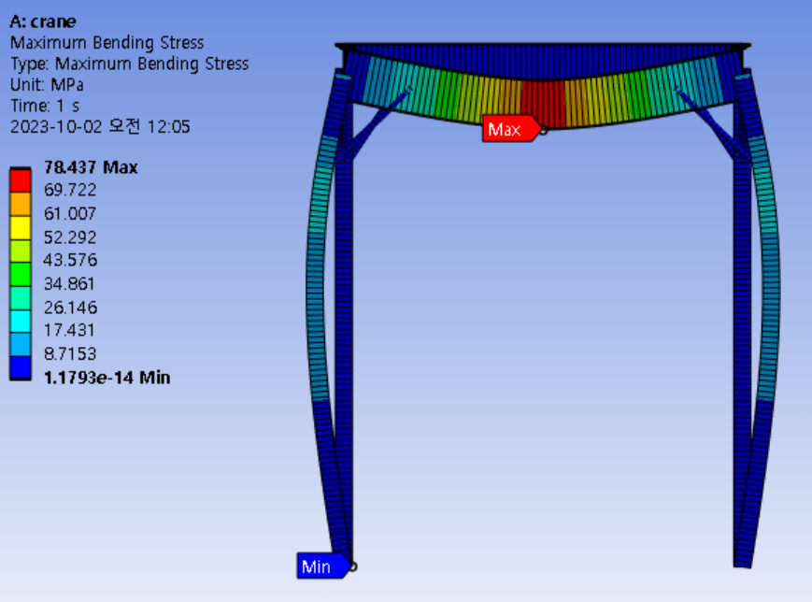 Safety Factor

|  |  |
| --- | --- |
| **Mode** | **Deflections** |
| Total | 2.537mm |
| X Axis | 0.597mm |
| Y Axis | 2.034mm |
| Z Axis | 2.534mm |

The beam deflections are less than 10mm, so it’s safe.

**2. Compare simulation results with appropriate theoretical results (stresses and downward deflections of the horizontal beam, critical buckling load of the columns)**

The following cross-sectional moments were obtained using the above formula.

|  |  |  |
| --- | --- | --- |
|  | Theoretical | Simulation |
| Stress of the horizontal beam |  | 78.437 MPa |
| Downward deflections of the horizontal beam |  | 2.5366mm |
| Critical buckling load of the columns |  |  |

The theoretical value and the simulation value came out similar.

**3. Discuss on boundary conditions of the four supports**

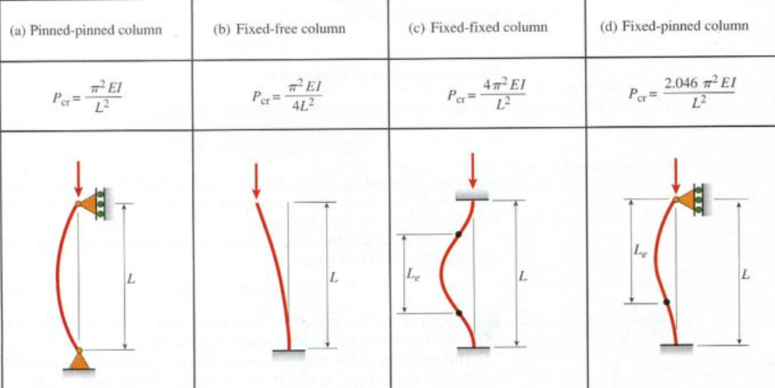

As you can see in the picture above, the buckling value comes out differently depending on the boundary condition. Therefore, buckling may occur better depending on the boundary conditions of the four supports of the crane. In the case of Fixed support, also called pinned support, The support is completely fixed to the ground, making it impossible to move and rotate. In the case of Roller support, it is fixed up and down, but it can be moved left and right. In the case of Hinge, it can't move from side to side, up and down, but only rotate.

**4. What do you think the function of the braces are?**

Brace distributes the load and reduces the stress concentration. This prevents the structure from being destroyed. In other words, it increases stability and strength.

**5. How many number of elements is required to accurately solve this problem?**

|  |  |  |
| --- | --- | --- |
| Mesh sizing | Elements | Simulation |
| 311.15(default) |  |  |
| 100 |  |  |
| 50 |  |  |
| 30 |  |  |
| 10 |  |  |

Changes in mesh sizing 50 or less did not appear as much as 50 or more. Element values differ when switching to values below 50, but total deformation changes are insignificant. Also, it takes a lot of time. Therefore, when the element number is 776 when the mesh sizing is 50, it is accurate.